About Sarvam Enviro Solutions Pvt. Ltd.
At Sarvam Enviro Solutions Pvt. Ltd., our core purpose is to be a one-stop solution for all environmental and sustainability needs. We believe the future of business and the planet are deeply interconnected, and in a world facing climate change, water scarcity, and resource challenges, we help organizations move beyond compliance to create meaningful, measurable impact. Our approach transforms sustainability from an obligation into a strategic opportunity for growth and resilience.
We partner with forward-thinking organizations to deliver end-to-end solutions across sustainable water management, carbon credit monetization, circular economy, environmental compliance, and. With water at the core of our approach and sustainability at the heart of everything we do, we enable businesses to optimize resources, enhance performance, and build a more responsible and future-ready enterprise.
Our Strategic Approach
At Sarvam Enviro Solutions Pvt. Ltd., we begin with in-depth analysis to understand requirements and identify opportunities. We design customized, practical solutions integrating sustainability, compliance, and resource efficiency. Our team ensures seamless execution using advanced technologies and proven methodologies. We provide continuous support through monitoring and optimization to drive long-term sustainable success.
Why Partner With Sarvam
Science-Driven Expertise
We combine technical knowledge with data-driven insights to deliver reliable and effective environmental solutions.
End-to-End Implementation
From assessment and design to execution and monitoring, we provide complete, integrated sustainability and water management solutions under one roof.
Innovative Technologies
We leverage advanced tools and modern methodologies to create efficient, future-ready environmental strategies.
Measurable Impact
Our solutions are designed to deliver tangible results — improving compliance, optimizing resources, and generating real business value.
Scalable & Sustainable Solutions
We build flexible, long-term solutions that grow with your business while ensuring environmental responsibility.
Add this section like below: when we click we will see description
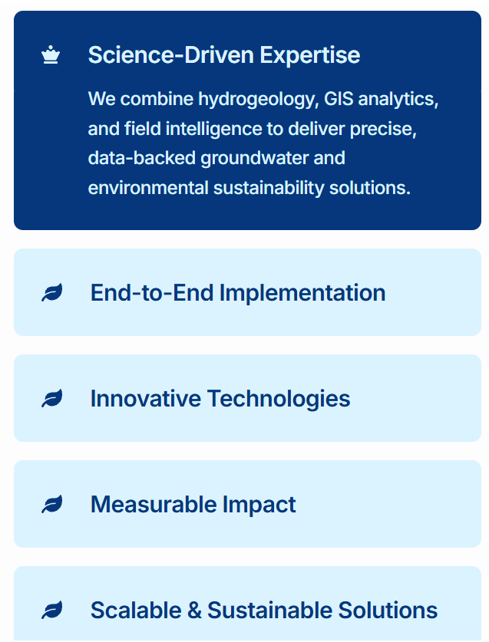
At the end this about us page add 
Services
- Sustainable Water Management
- Effluent Treatment Plant (ETP)
We design and implement efficient Effluent Treatment Plants (ETP) to treat industrial wastewater, ensuring compliance with environmental regulations while enabling safe discharge or reuse. Our solutions focus on optimizing treatment performance, reducing operational costs, and supporting sustainable industrial practices.
- Sewage Treatment Plant (STP)
Our Sewage Treatment Plant (STP) solutions are designed to effectively treat domestic wastewater using advanced and reliable technologies. We help organizations achieve regulatory compliance while promoting water reuse for landscaping, flushing, and other non-potable applications.
- Zero Liquid Discharge (ZLD)
We provide comprehensive Zero Liquid Discharge (ZLD) systems that eliminate wastewater discharge by recovering and reusing water within the process. Our solutions help industries achieve maximum water efficiency, minimize environmental impact, and meet stringent regulatory standards.
- DM Plant (Demineralization Plant)
Our Demineralization (DM) Plants are engineered to remove dissolved salts and impurities, delivering high-purity water for industrial applications. We ensure consistent performance, operational efficiency, and long-term reliability for critical processes.
- RO & UF Plant (Reverse Osmosis & Ultrafiltration)
We offer advanced Reverse Osmosis (RO) and Ultrafiltration (UF) systems for effective water purification and treatment. These technologies help remove contaminants, improve water quality, and enable reuse across various industrial and commercial applications.
- Rainwater Harvesting
Our rainwater harvesting solutions are designed to capture, store, and recharge groundwater, helping organizations reduce dependency on external water sources. We promote sustainable water conservation practices that contribute to long-term water security.
- Annual Maintenance Contracts (AMC)
We provide comprehensive AMC services for all water treatment systems, ensuring smooth operation, regular monitoring, and timely maintenance. Our support helps enhance system efficiency, extend equipment life, and ensure uninterrupted compliance and performance.

- MPCB Consent & Environmental Compliance
We provide end-to-end support for MPCB consents and environmental compliance, ensuring smooth approvals and full regulatory adherence. Our expertise covers a wide range of authorizations, enabling businesses to navigate complex regulations with ease.
- Consent to Establish (CTE)
- Consent to Operate (CTO)
- Consent Renewal Services
- E-Waste Authorization
- Hazardous Waste Authorization
- Bio-medical Waste Authorization
- Plastic Waste Authorization
- Battery Recycler Authorization
With a strong understanding of MPCB, CPCB, and MoEF norms, we help businesses stay compliant while minimizing delays and complexities.

Regulatory Returns & EPR Services
We simplify environmental reporting and compliance through structured, efficient, and reliable systems, helping organizations meet statutory requirements without operational burden.
- E-Waste Return (Form 3)
- Hazardous Waste Annual Return (Form 4)
- Environmental Status Report (Form 5)
- Bio-medical Waste Annual Return
- Online Manifest Submission (Form 10)
- Extended Producer Responsibility (EPR)
- Online Logbook System
- Battery Return Services
Our services ensure accurate documentation, timely submissions, and complete compliance with regulatory frameworks. By streamlining reporting processes and integrating digital solutions, we enable businesses to focus on operations while maintaining full environmental accountability.

- ESG and Sustainability Services
- Assessment
We begin by evaluating your current environmental and sustainability performance to identify gaps, risks, and opportunities for improvement.
- ESG Assessment & Gap Analysis
- GHG Emissions Assessment
- Resource & Energy Efficiency Analysis
- Regulatory Compliance Review
- Materiality Assessment
- Reporting & Strategy
We support organizations in developing robust sustainability frameworks and reports aligned with global standards and regulatory requirements.
- ESG Strategy & Framework Development
- Sustainability Reporting (BRSR, GRI, etc.)
- Net Zero & Decarbonization Strategy
- Policy Development & Implementation
- Environmental Compliance Integration

- Turn Sustainability into Revenue
4.1 Carbon Project Development
We design, develop, and implement high-integrity carbon credit projects across nature-based and technology-driven solutions. Our approach combines scientific methodologies, strong on-ground execution, and community engagement to create projects that deliver measurable environmental impact and long-term financial value.
From concept to implementation, we ensure your project is structured to meet global standards and generate verified carbon credits.
Our Capabilities
- Feasibility Studies & Baseline Assessment
Evaluate project viability, carbon potential, and financial returns before execution.
- Project Design & Methodology Selection
Development of projects across afforestation, regenerative agriculture, biochar, and waste-to-energy aligned with recognized standards (e.g., Verra, Gold Standard).
- Regulatory Approvals & Government Liaisoning
End-to-end support for approvals including Letters of Authorization (LOA), NOCs, and coordination with relevant authorities.
- Community Engagement & Implementation
Strong partnerships with farmers, FPOs, NGOs, and local stakeholders to ensure scalable and sustainable project execution.
4.2 Carbon Credit Management & Monetization
Convert Carbon Projects into Revenue Streams
We provide end-to-end carbon credit lifecycle management, enabling organizations to transform sustainability initiatives into tradable financial assets. Our expertise ensures your project meets international standards, achieves certification efficiently, and connects with the right buyers in global markets.
Our Capabilities
- Monitoring, Reporting & Verification (MRV)
Robust systems for tracking emissions reduction, data management, and transparent reporting.
- Certification & Issuance
End-to-end coordination with global standards such as Verra and Gold Standard to validate and issue carbon credits.
- Carbon Credit Trading & Sales Strategy
Strategic positioning, pricing, and sale of carbon credits in voluntary and compliance markets.
- Global Buyer Access
Established network of buyers across Europe, Japan, and other international markets.
4.3 Circular Economy & Environmental Compliance
Turn Compliance Requirements into Business Opportunities
We help organizations navigate complex environmental regulations while unlocking value through circular economy solutions. Our approach integrates compliance with revenue-generating mechanisms, enabling businesses to reduce waste, improve sustainability performance, and create new value streams.
Our Capabilities
- Plastic Credit Solutions
Design and implementation of projects that generate verified plastic credits aligned with global standards.
- Extended Producer Responsibility (EPR) Advisory & Trading
End-to-end support for EPR compliance, including strategy, documentation, and credit trading.
4.4 Renewable Energy Certificate (IREC) Services
Monetize Your Renewable Energy Potential
We support renewable energy producers and organizations in registering and trading International Renewable Energy Certificates (IRECs), enabling them to unlock additional revenue while contributing to global clean energy goals.
Our Capabilities
- IREC Registration & Documentation
Complete support for registering renewable energy assets under IREC frameworks.
- Compliance & Verification Support
Ensuring alignment with international standards and smooth certification processes.
- IREC Trading & Monetization
Access to buyers and markets for effective trading of renewable energy certificates.

- Environmental Monitoring
We provide comprehensive environmental monitoring solutions to help organizations track, manage, and comply with regulatory standards while ensuring environmental protection and operational efficiency. Our services are designed to deliver accurate data, actionable insights, and reliable reporting for informed decision-making.
- Air Quality Monitoring (Ambient & Stack)
- Water & Wastewater Analysis
- Noise Level Monitoring
- Soil & Groundwater Testing
- Emission & Effluent Monitoring
- Environmental Data Analysis & Reporting
Our approach combines advanced monitoring techniques with regulatory expertise to ensure precise assessments and timely compliance. By enabling continuous monitoring and data-driven insights, we help businesses minimize environmental risks, maintain compliance, and improve overall sustainability performance.

Add one : for free consultation call 8329006561

